AP Chemistry: Chapter 6 Student Notes—Atomic Theory

Objectives
- 7.1a: What do we know about Atoms
- 7.1: Electromagnetic Radiation
- 7.2: The Nature of Matter
- 7.3: Atomic Spectrum of Hydrogen
- 7.4: The Bohr Model
- 7.5-7.7: Quantum Mechanics
- 7.10: Periodic Table
- 7.11: Aufbau Principle and the Periodic Table
- 7.12: Periodic Trends in Atomic Properties

7.1a: What do we know about Atoms?

Size: How many atoms in an orange?
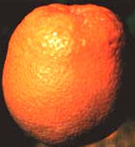→

Nucleus


Mass of atomic particles

7.1: Electromagnetic Radiation

Light travels as a _____________
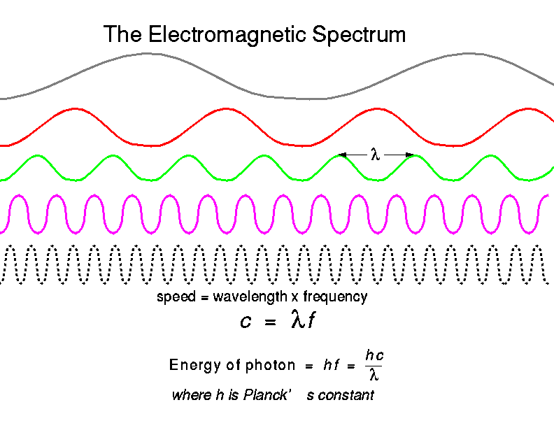

Parts of a wave

Wavelength

Frequency

Velocity

Amplitude

Light Equations

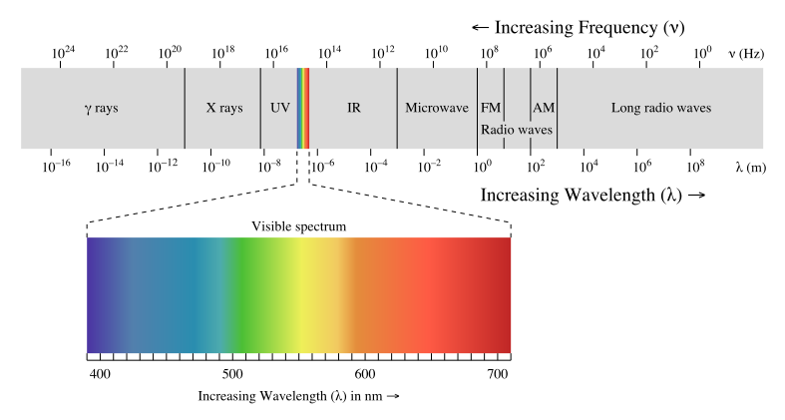
7.2: The Nature of Matter

Watch Video Clip: Mindwalk

How does matter behave? It acts like a _________________

But….
Enter Max Planck (1858-1947)

∆E=nhν

Energy is _____________ized

What does this mean?

Energy comes in small quantities called _______________

So what about light?

Light travels as a ___________________ and as a ________________

A particle of light is called a ____________________
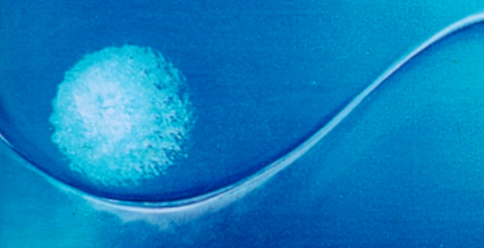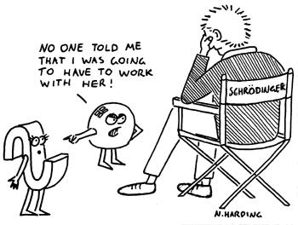
Does light have mass?
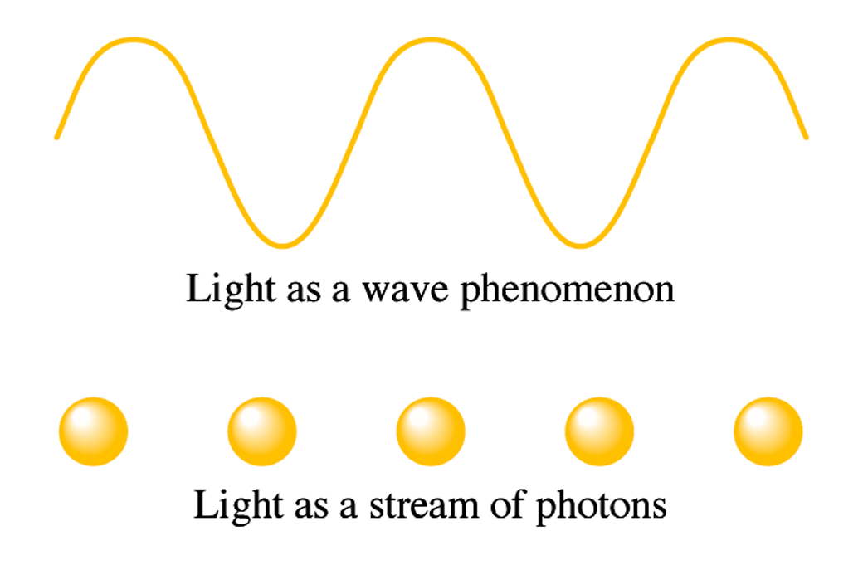
7.3: Atomic Spectrum of Hydrogen
How does a spectrum work?


What is different about hydrogen?

Why does this crazy thing happen?

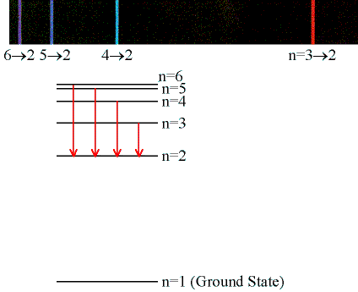
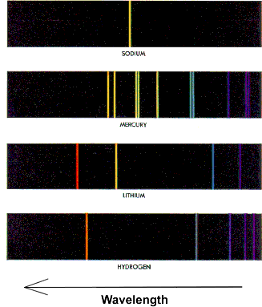
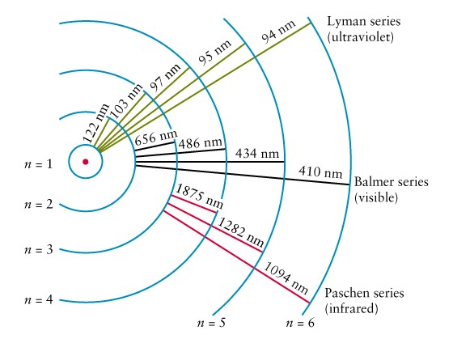
7.4: The Bohr Model
Bohr sat and did some _____________

He came up with the equation:

Example 1
Calculate the energy required to excite the hydrogen electron from level n=1 to level n=2. Also calculate the wavelength of light that must be absorbed by a hydrogen atom in its ground state to reach this excited state.

The Bohr model works great for hydrogen
but….

The problem with multi-electron atoms
7.5-7.7: Quantum Mechanics
This answers the question:
Where is the _____________ in the atom

The answer is complex

We can’t say exactly where the atom is…
We can only say where we think it _________ be.

Developed by Werner Heisenberg (1901-1976), Louis De Broglie (1892-1987), Erwin Schrodinger (1887-1961)

Schrodinger made an equation from the hydrogen data: His answers were ___________. Not lines. Those shapes were ________________ distributions.

Those shapes can be drawn in 3 dimensions:
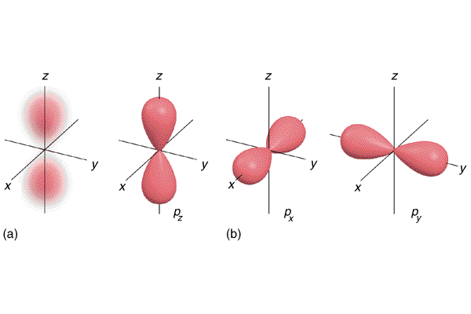
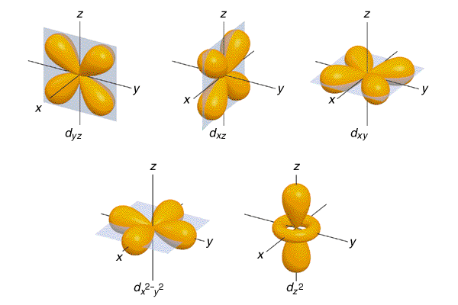
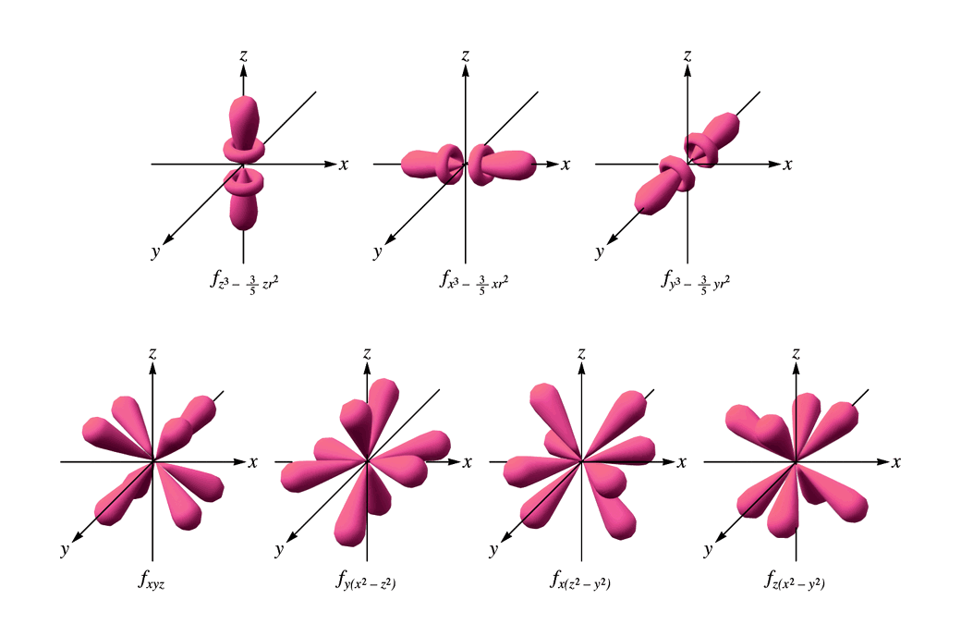
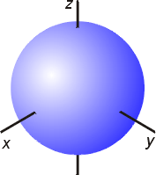
Shapes come from a mathematical ________________

That has variables called _____________ _________________

Like an address
n=

l=

m_{l}=

m_{s}=

name | symbol | orbital meaning | range of values | value example
principle quantum number |  | shell
azimuthal quantum number (angular momentum) |  | subshell |  | for :
magnetic quantum number, (projection of angular momentum) |  | energy shift |  | for :
spin projection quantum number |  | spin |  | for an electron, either:

Quantum Number Practice

7.10-7.l1: Periodic Table—History
Originally elements were grouped only because of their similar properties:

Done by Dimtri _______________ (1834-1907)

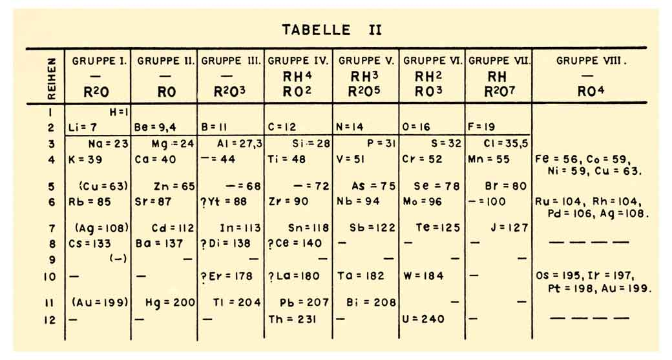

Dimitry predicted that some elements would be discovered later due to gaps in his table.

7.11: Aufbau Principle and the Periodic Table
Electron Configurations

Read the periodic table like a book
______________ to ___________________

______________ to ___________________

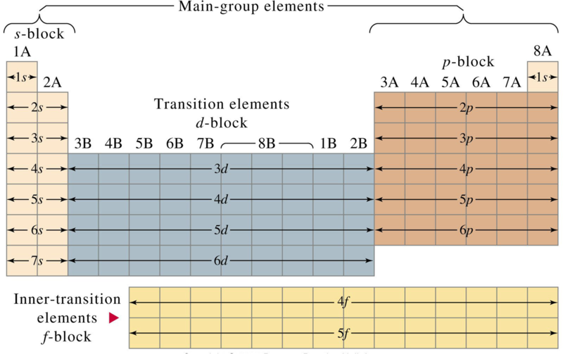

Practice: Write electron configurations of several elements
Exceptional Electron Configurations (Those that don’t fit the pattern—exceptions)

Chromium Family

Copper Family

Why?
Stable Orbital’s
Full Orbital’s are the ____________ stable
½ full orbital’s are also ____________

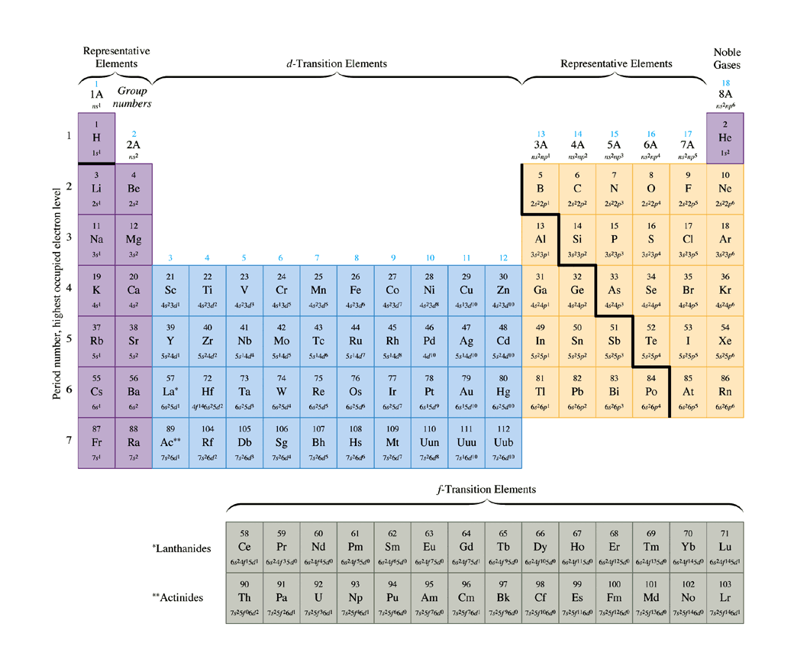

7.12: Periodic Trends in Atomic Properties

Atomic Size

Which atoms are larger than others?: The Girdle theory

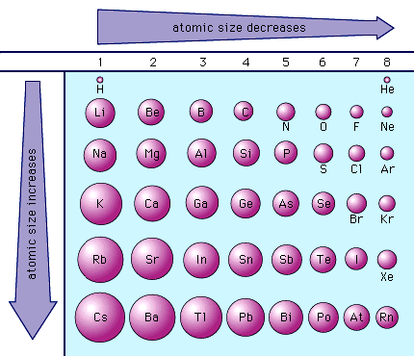

Why?
Ionization Energy =

Trend
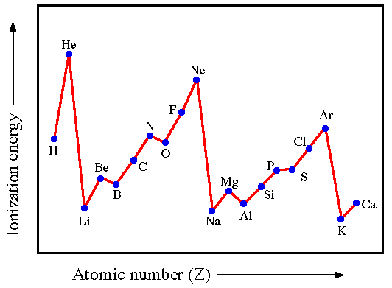

Trend

First Ionization Energy =

2nd Ionization Energy =

3rd Ionization Energy =

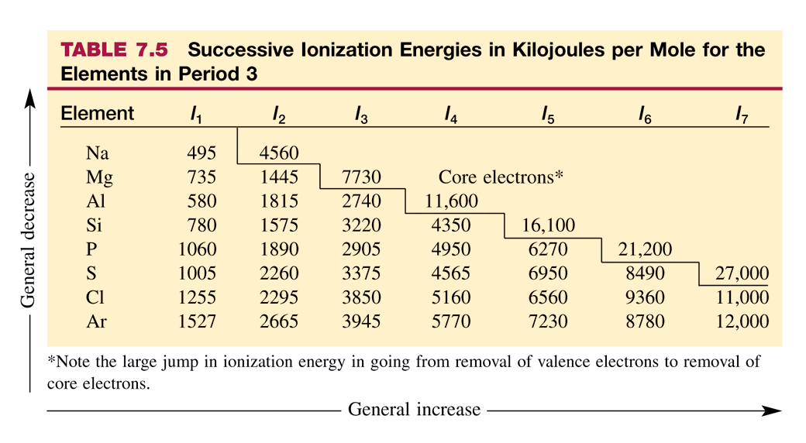

Two Questions—It all comes back to size!!

- Why does the Energy increase as you increase the number of electrons removed from the atom?

- Why is there such a big jump in energies in certain portions of the table above?
Miscellaneous Atomic Theory Questions

Why is the ionization energy of oxygen lower than that of nitrogen?

Why is the ionization energy of Aluminum lower than that of Magnesium?

Electron Affinity =

Trend

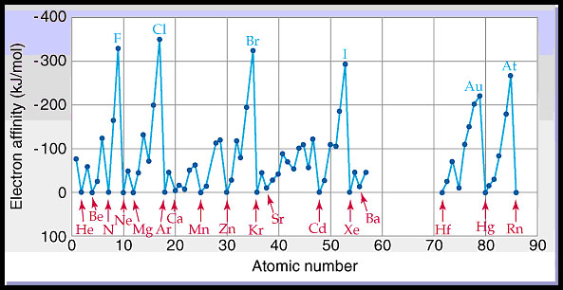

AP Style Questions: All short Essay
1987 D
Two important concepts that relate to the behavior of electrons in atom systems are the Heisenberg uncertainty principle and the wave–particle duality of matter.
(a) State the Heisenberg uncertainty principle as it related to the determining the position and momentum of an object.
(b) What aspect of the Bohr theory of the atom is considered unsatisfactory as a result of the Heisenberg uncertainty principle?
(c) Explain why the uncertainty principle or the wave nature of particles is not significant when describing the behavior of macroscopic objects, but it is very significant when describing the behavior of electrons.

1990 D
The diagram shows the first ionization energies for the elements from Li to Ne. Briefly (in one to three sentences) explain each of the following in terms of atomic structure.
(a) In general, there is an increase in the first ionization energy from Li to Ne.
(b) The first ionization energy of B is lower than that of Be.
(c) The first ionization energy of O is lower than that of N.
(d) Predict how the first ionization energy of Na compares to those of Li and of Ne. Explain.
1993 D
Account for each of the following in terms of principles of atom structure, including the number, properties, and arrangements of subatomic particles.
(a) The second ionization energy of sodium is about three times greater than the second ionization energy of magnesium.
(b) The difference between the atomic radii of Na and K is relatively large compared to the difference between the atomic radii of Rb and Cs.
(c) A sample of nickel chloride is attracted into a magnetic field, whereas a sample of solid zinc chloride is not.
(d) Phosphorus forms the fluorides PF3 and PF5, whereas nitrogen forms only NF3.
AP Chemistry: Chapter 8 Student Notes—Bonding

Objectives
- 8.1: Types of Chemical Bonds
- 8.2: Electronegativity
- 8.3: Bond Polarity and Dipole Moments
- 8.4: Ions: Electron Configurations and Sizes
- 8.5: Formation of Binary Ionic Compounds
- 8.8: Covalent Bond Energies
- 8.10: Lewis Structures
- 8.11: Exceptions to the Octet Rule
- 8.12: Resonance
- 8.13: VSEPR Model and Shapes
- 9.1: Hybridization and the Localized Electron Model

8.1: Types of Chemical Bonds

Introduction to Bonding Type
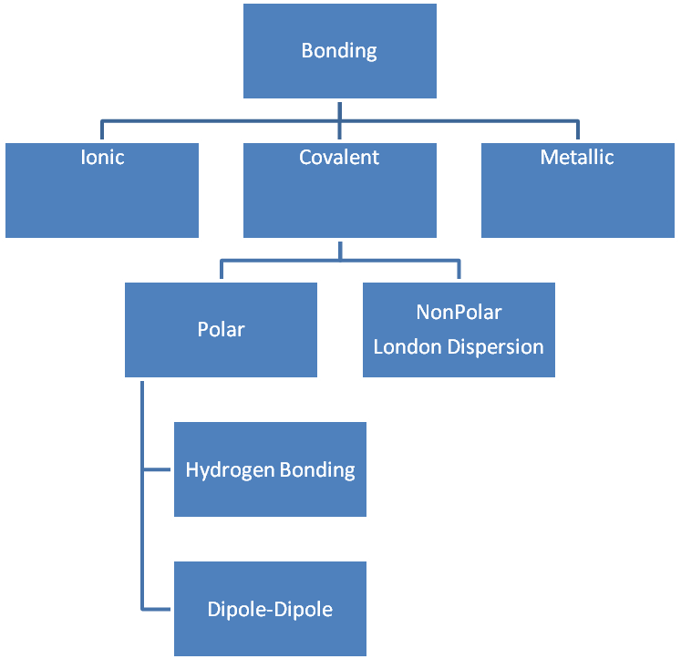
The Key: Coulomb’s Law
What holds thing together is
_______________ attraction

Ionic Bond Diagram
____________ of valence electrons

Covalent Bond Diagram
____________ of valence electrons

Metallic Bond Diagram
____________ of valence electrons
Bond Energy and Bond Distance of a Covalent Bond
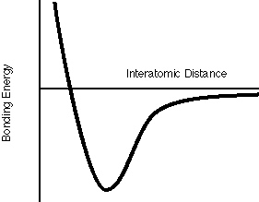

8.2: Electronegativity

Definition

Trend

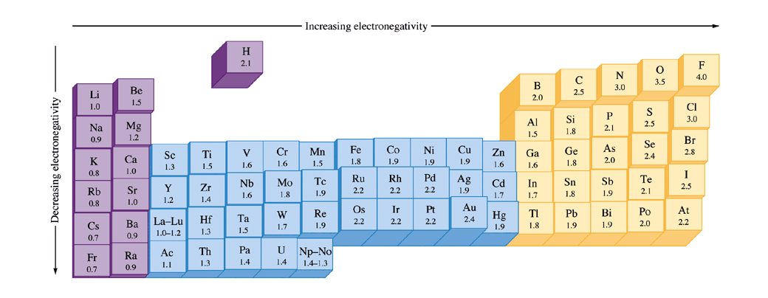
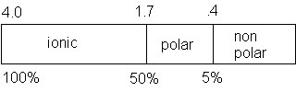

8.3: Bond Polarity and Dipole Moments

Dipole =

Dipole Moment =

Polar bond =

Polar Molecule
Bond must be _________________

Shape must not ________________

Examples of Polar molecules

H₂O is polar

NH₃ is polar

CO₂ is not polar

8.4: Ions: Electron Configurations and Sizes

Ions have __________________ sizes than ____________________

Cations of the same element are ___________________.

Anions of the same element are ____________________.

Why? Draw pictures here and discuss electrons and electron clouds.
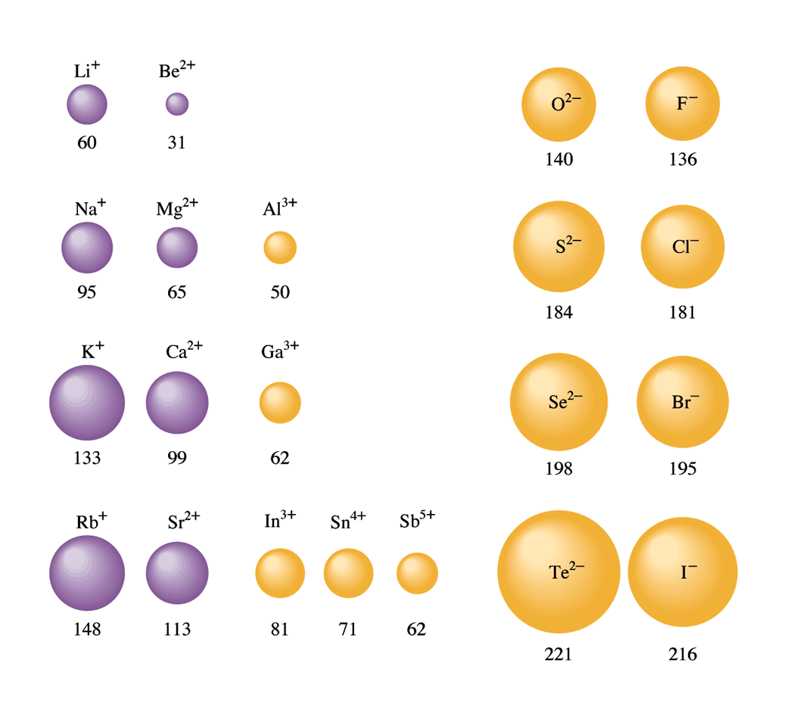

Example 1: Rank the following in order from smallest to largest:
Na⁺, Mg²⁺, Al³⁺O²⁻, F⁻, Ne

8.5: Formation of Binary Ionic Compounds

This section looks that the energies involved in the formation of ionic bonds

Lattice Energy: ____________________________________
For the Reaction:
M⁺ (g) + X⁻(g) → MX(s)

Steps to make this happen: Start with the metal in it’s standard state and the anion in its standard state: Each step requires energy (or releases in some cases)
Example: The formation of lithium fluoride

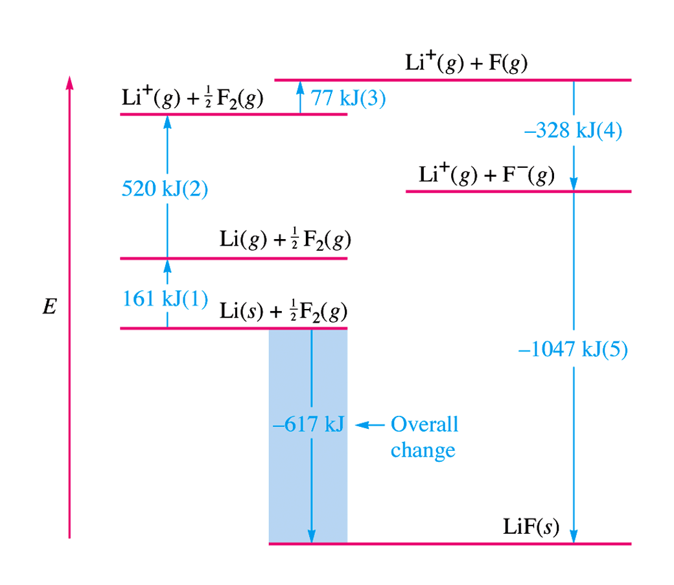

8.8: Covalent Bond Energies
Four ways to calculate ∆H
- Hess Law version 1:
- Hess Law Version 2: Add Reactions Method
- Calorimetry:
- Bond Energies: This is what this section is about

∆H =Bonds Broken – Bonds Formed
= Reactants bonds – Products Bonds

A Quick Lesson in Organic Chemistry—Drawing Structural Formulas

Chemical | Number of Bonds
Halides + Hydrogen | 1
Oxygen, Sulfur | 2
Nitrogen, Phosphorous | 3
Carbon | 4

Examples
Calculating Bond Energies:
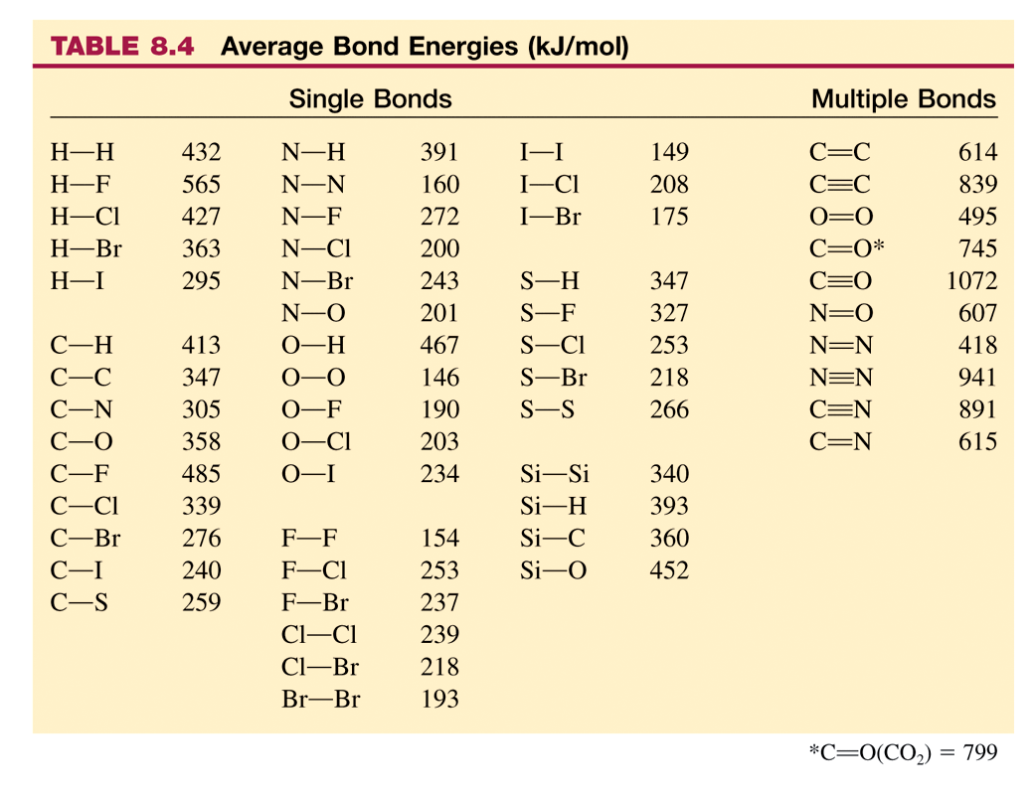

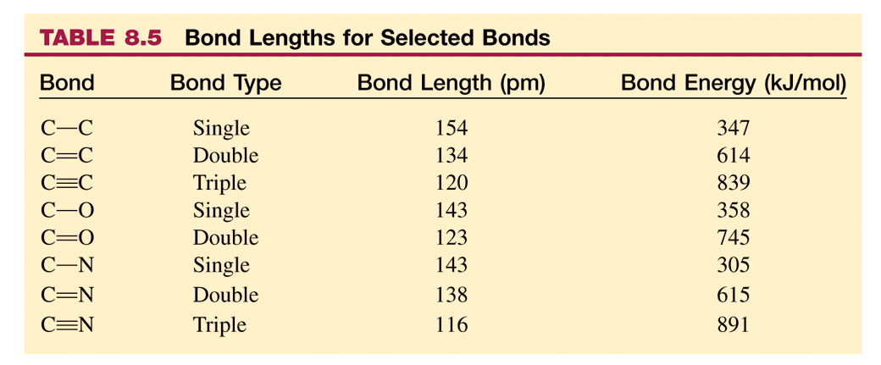
Example 1
Calculate ∆H for the following reaction:
CH₄(g) + 2Cl₂(g) + 2F₂(g) → CF₂Cl₂(g) + 2HF(g) + 2HCl(g)

Example 2:
Calculate ∆H for the following reaction:
5N₂O₄ + 4N₂H₃CH₃ → 12H₂O + 9N₂ + 4CO₂

Example 3:
Use the following standard enthalpies of formation to estimate the N-H bond energy in ammonia: N(g), 472.7 kJ/mol, H(g), 216.0 kJ/mol, NH₃(g), -46.1 kJ/mol. Compare your value to the one in the table. Account for differences.
8.10: Lewis Structures

Definition: Lewis Structure

Definition: Octet Rule

Rules for Drawing Lewis Structures
- Count the total number of valence electrons (Including electrons related to polyatomic ions)
- Distribute one bond to all necessary connections
- Distribute pairs of electrons to external atoms
- All extra electrons go on the central atom.
- If necessary add double or triple bonds to fulfill the octet rule.

Examples

8.11: Exceptions to the Octet Rule
What happens when you have more/less electrons than 8?

Examples

8.12: Resonance
Definition: Resonance

Definition: Resonance Structures

Examples

Formal Charge
Assign a formal charge to each atom in a molecule or ion by:
- Number of Valence Electrons Typically associated with that atom
- Subtract the total number of electrons around that atom
- Subtract the number of bonds connected to that atom.

The Best structures have the formal charges closest to zero for all atoms

Example 1: Sulfate
Example 2: HCN

Example 3: ClO₃⁻

8.13: VSEPR Model and Shapes

Shapes = Molecular Geometry= molecular structure

VSEPR =

This means that valence electrons __________________________________

Why?

It all depends on the number of “clouds” (effective pairs) around an atom.

Activity: Spheres and Shapes.

Molecular Shapes.
AP Chemistry
Sp | 2 | Linear Diatomic, Usually nonpolar CO₂, HCN |  |  |  | Remember that in molecules where the outside molecules are different, shapes that tend to be nonpolar usually become polar.
Sp² | 3 | Trigonal Planar: BF₃, SO₃²⁻, NO₃⁻ 120˚ | Bent, 12O˚ Usually polar  NO₂⁻ |  |  | Also: If there ever is a two molecule atom (diatomic) that molecule’s polarity depends upon the electronegativity difference of the atoms
Sp³ | 4 | Tetrahedral; 109˚: Usually nonpolar CH₄CF₄ | Pyrimidal: 107˚ Usually polar: NH₃, PCl₃ | Bent: 104.5˚  Usually polar: H₂O, OF₂ |  | Remember to count the number of “effective pairs” of electrons, not the actual number of electrons. A double or triple bond counts as one effective pair.
Sp³d | 5 | Trigional bipyrimidal: Usually nonpolar 120˚ and 90˚: PCl₅ | See-saw: Usually polar: 120˚, 90˚, SeF₄ | T-Shaped: Usually polar, 90˚ bond angles | Linear Triatomic: Usually nonpolar: 180˚, 90˚
Sp³d² | 6 | Octahedral: Usually nonpolar: 90˚, PCl₆  SbF₆ | Square Pyrimidal: Usually polar, 90˚, IF₅ | Square Planar: Usually nonpolar, 90˚  XeF₄ | T-Shaped:  Usually polar  90˚ bond angles | Linear Triatomic:  Usually nonpolar: 180˚, 90˚  I₃¹⁻

Shapes and Polarity

Draw the Lewis structures of each: Determine the molecular geometry (shape), and the polarity.

9.1: Hybridization and the Localized Electron Model

Definition: Hybridization

Hybrid Orbitals:

Has to do with atoms having different orbitals (s, p, d, f) shapes than molecules (molecular orbitals)

sp³
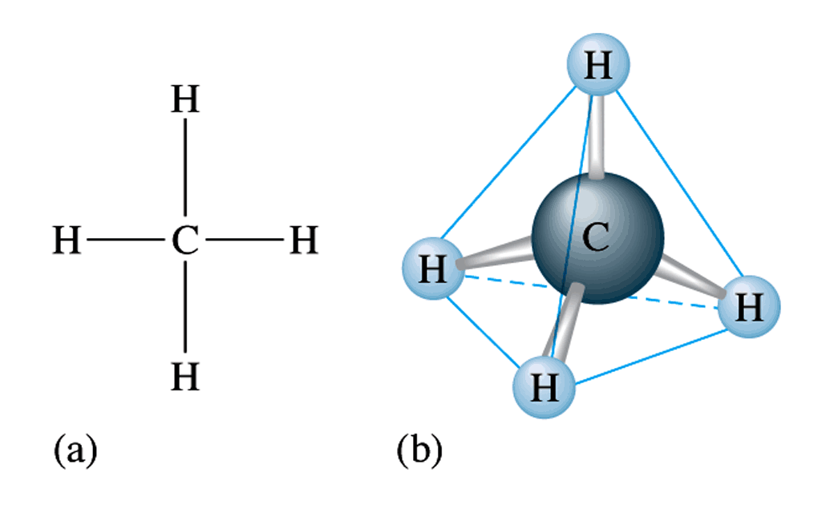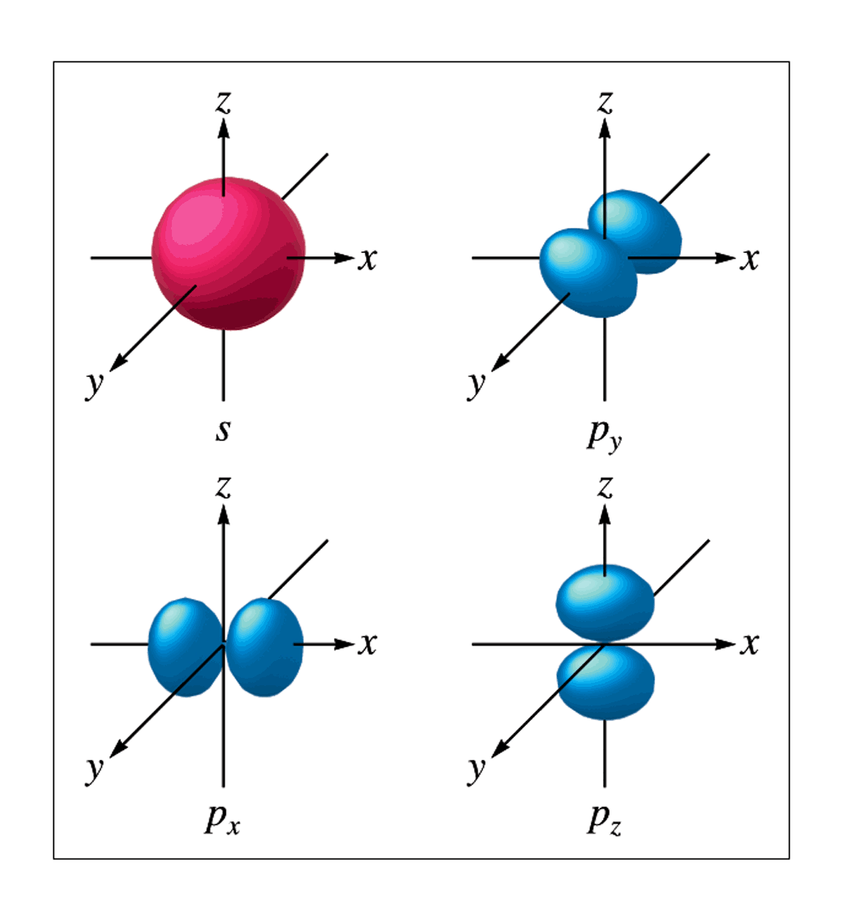

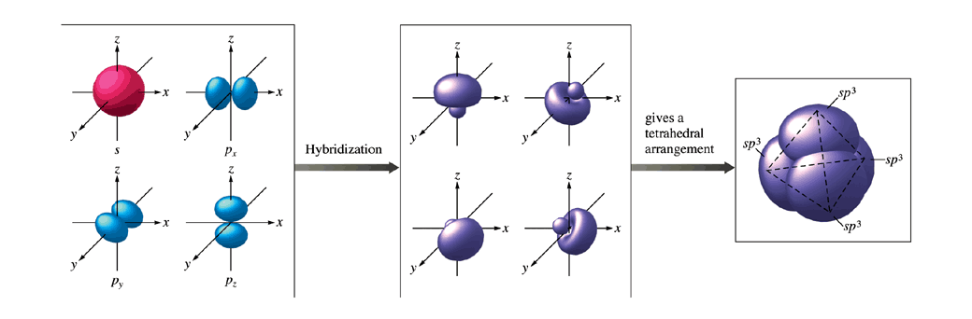
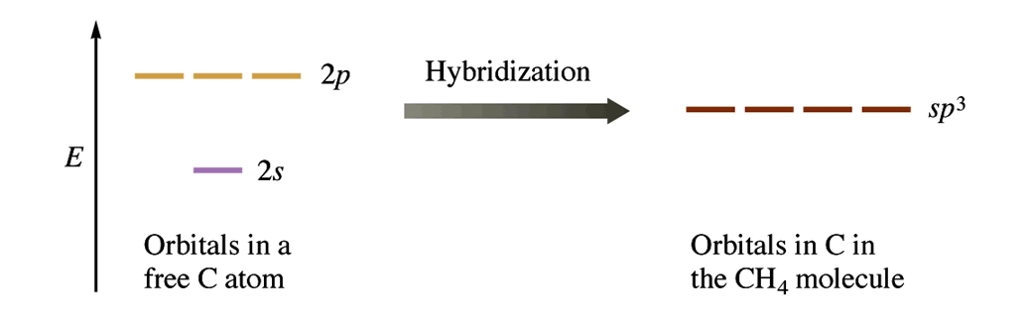
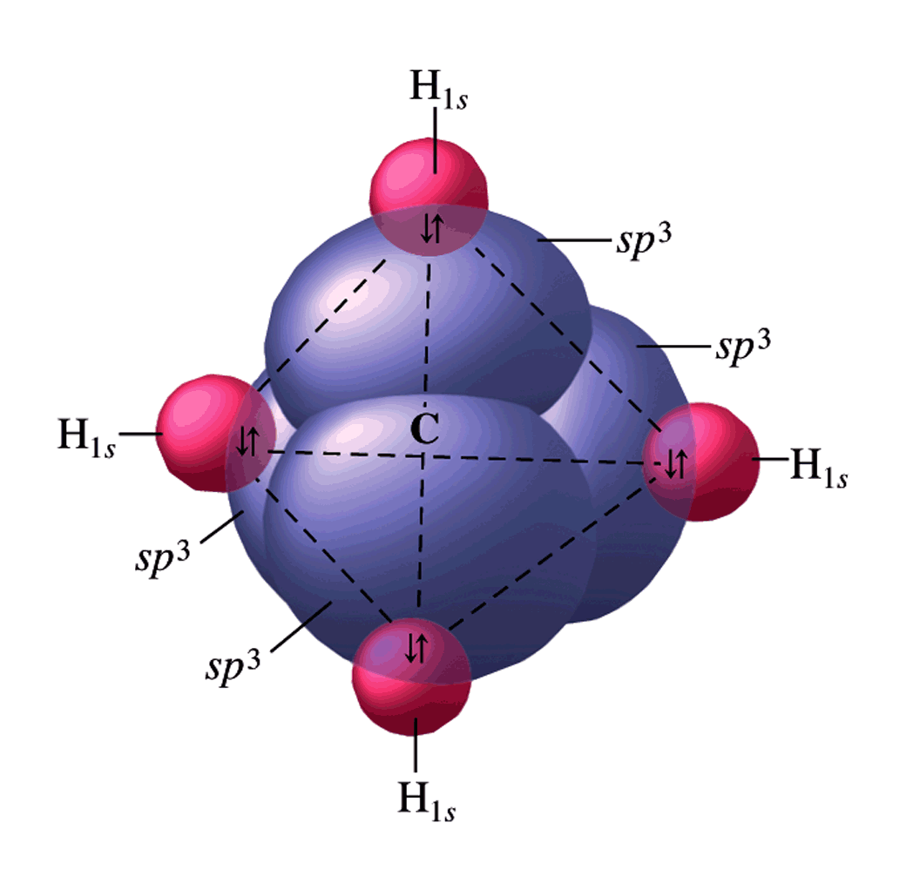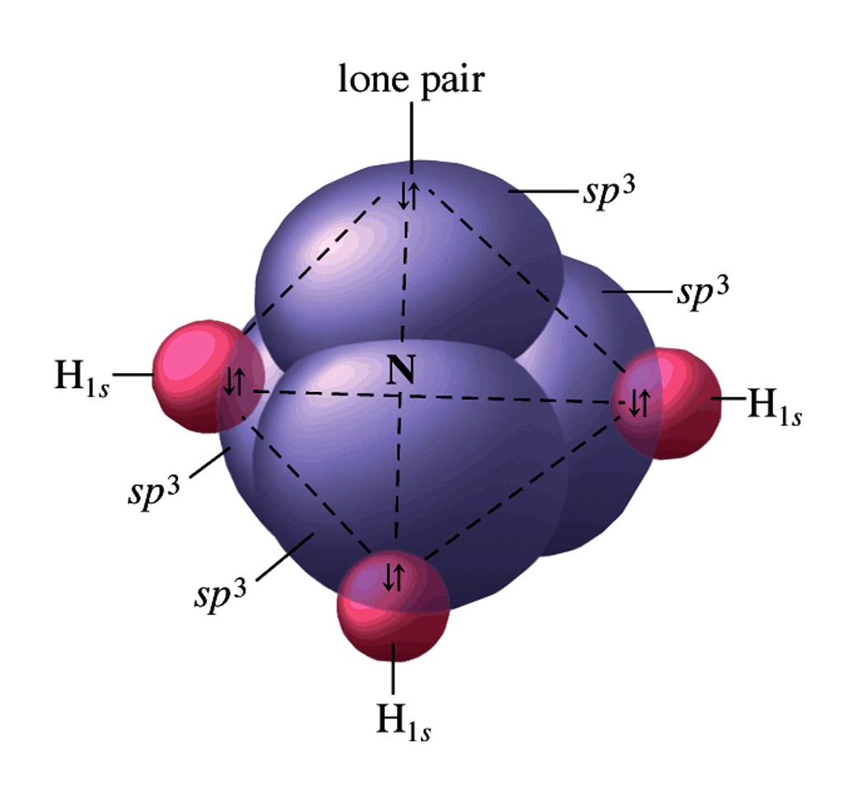

sp²
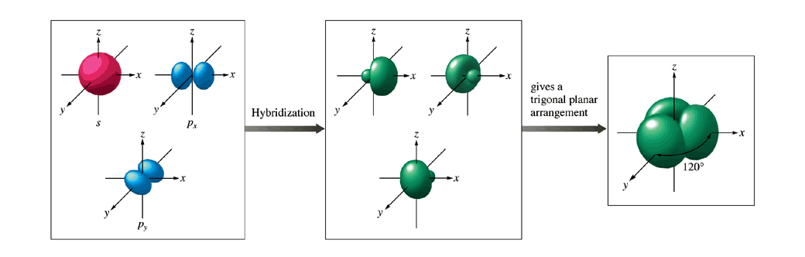
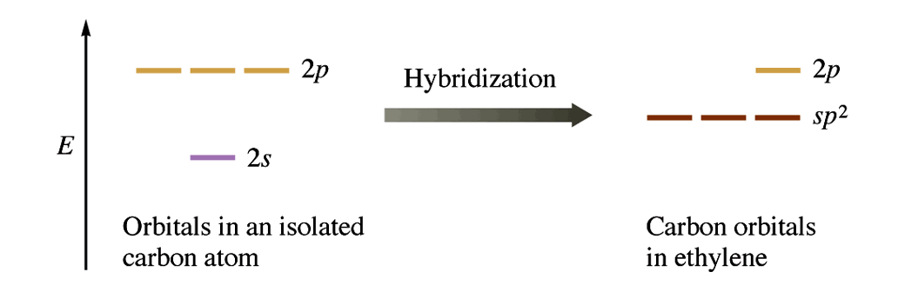
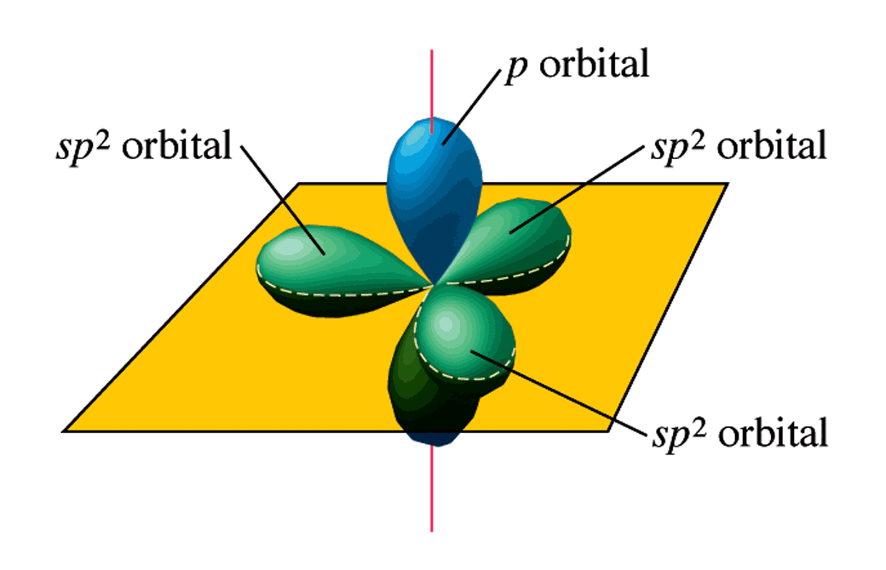
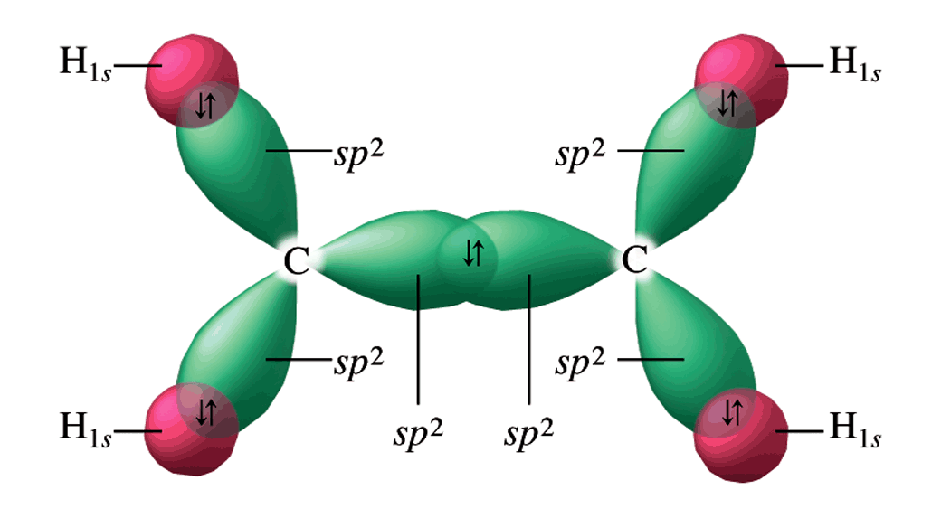

Sigma Bond =

Pi Bond =

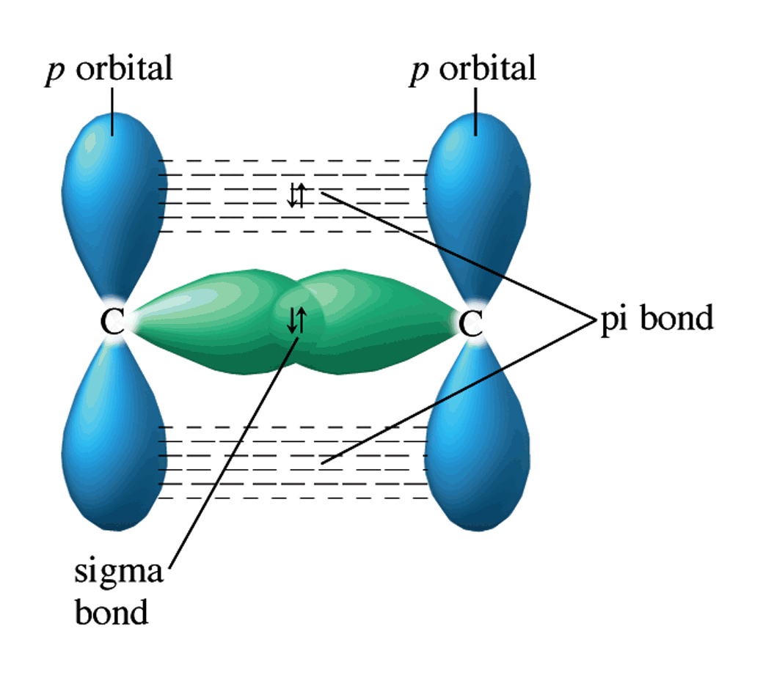
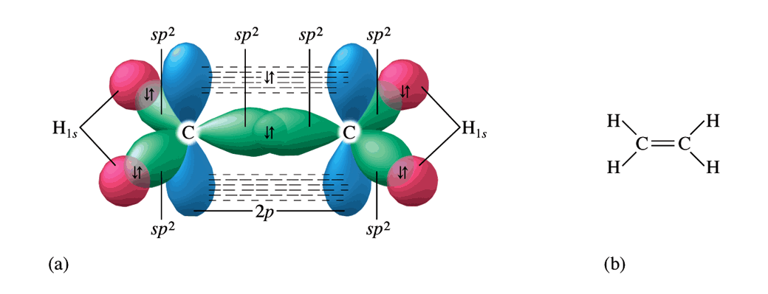

sp
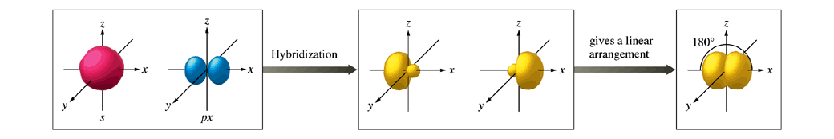
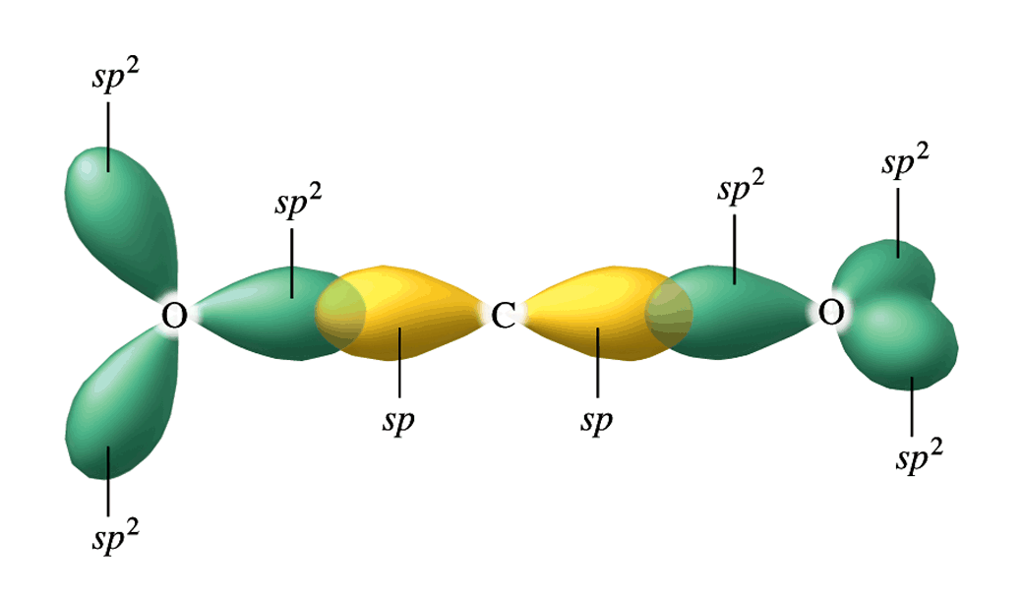
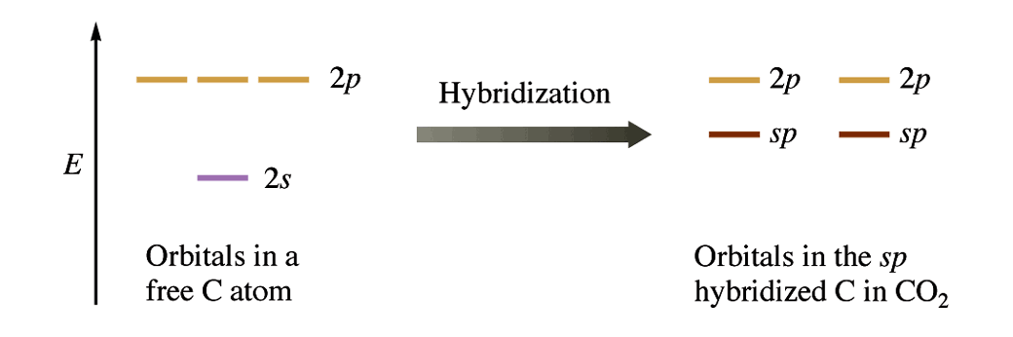
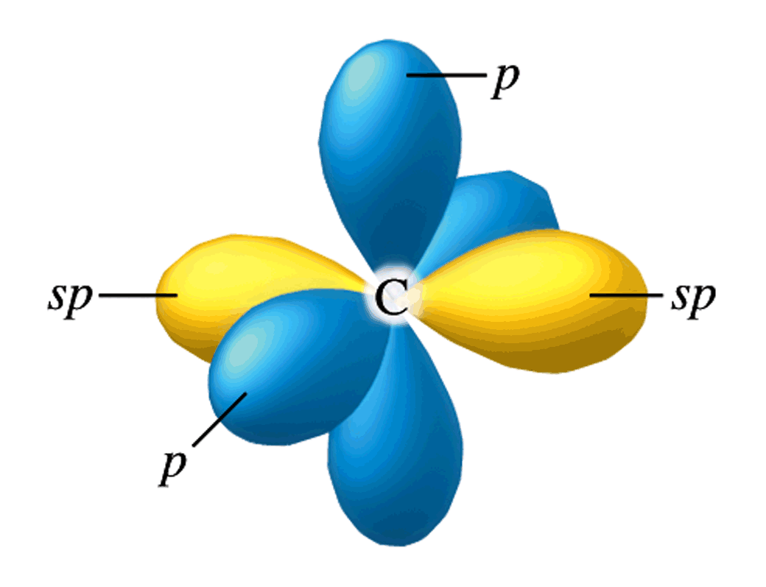
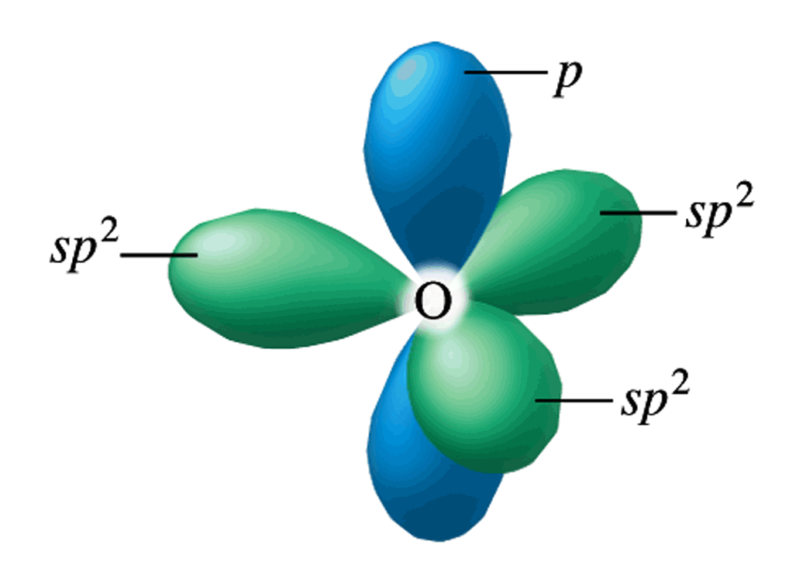
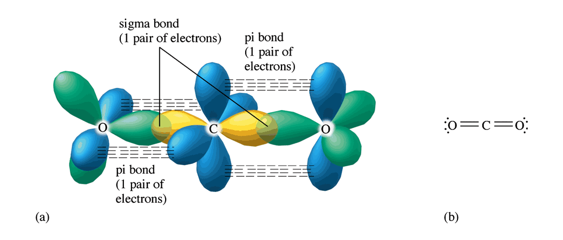
dsp³
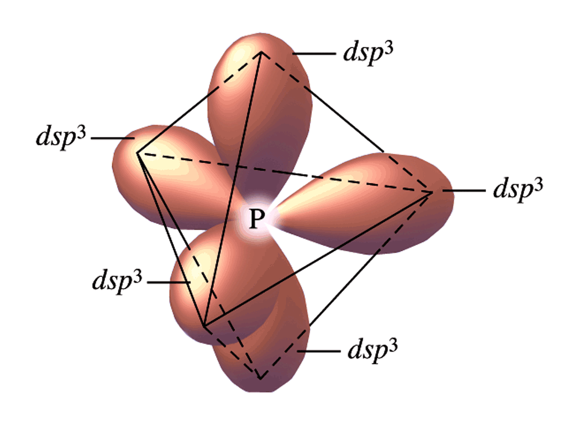

d²sp³
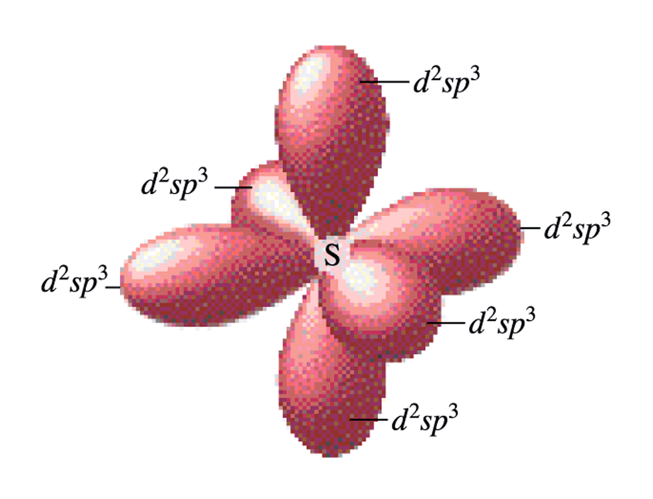
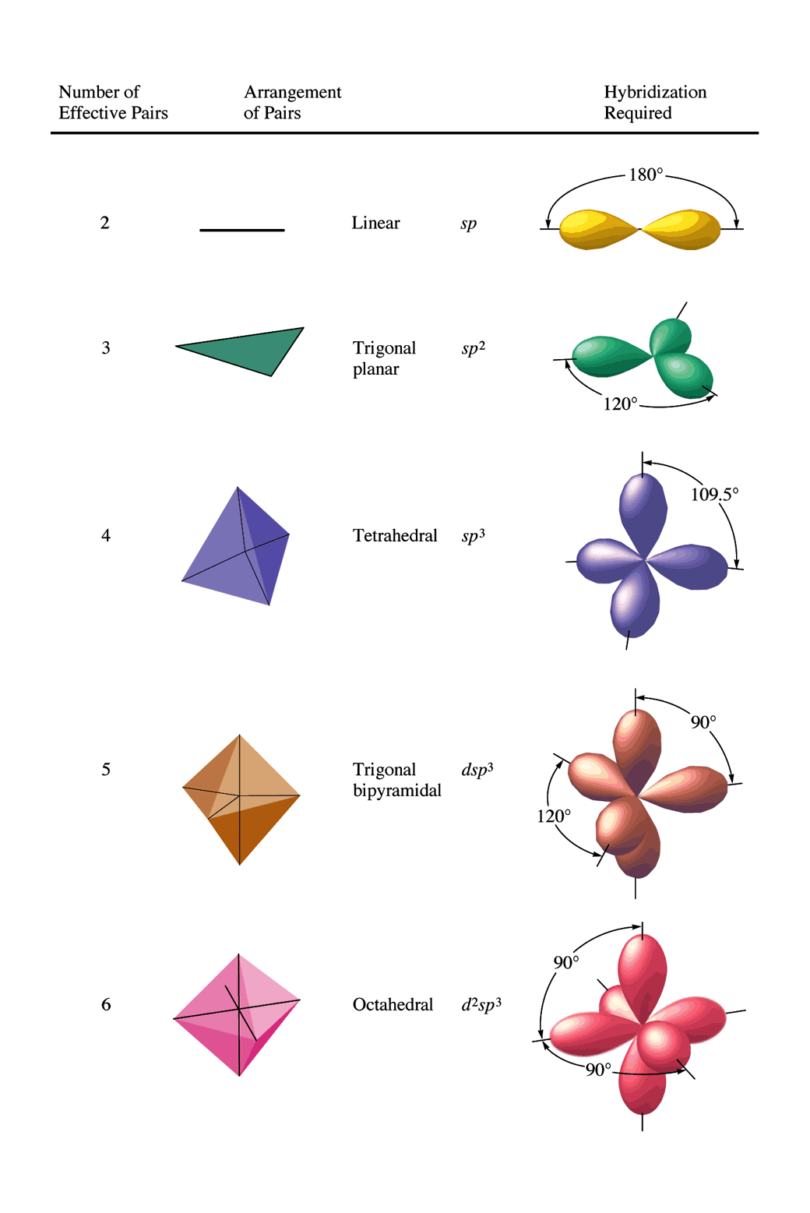
AP Style Questions
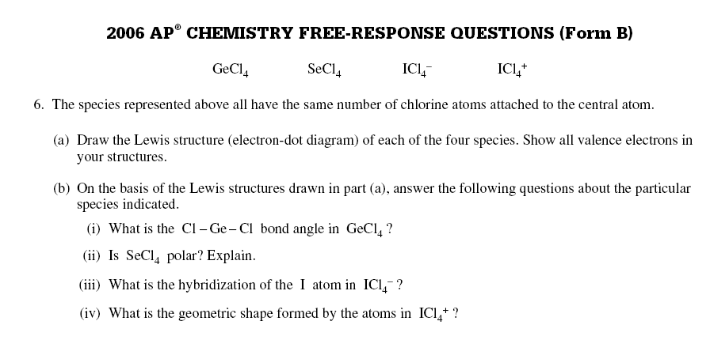
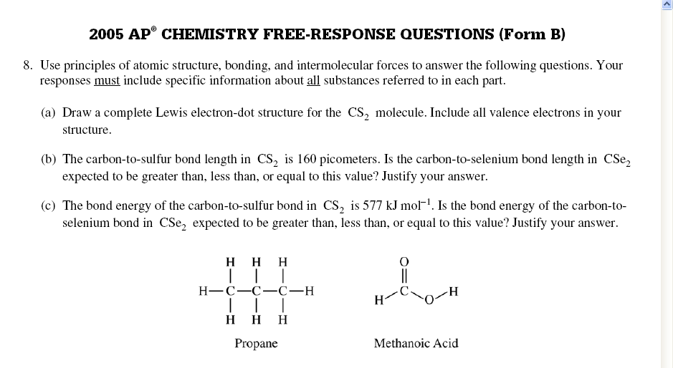
- Determine
  - The number of sigma pi bonds in both propane and methanonic acid.
  - The hybridization around each carbon in propane
  - The hybridization around the O in methanoic acid
10.1: Intermolecular Forces
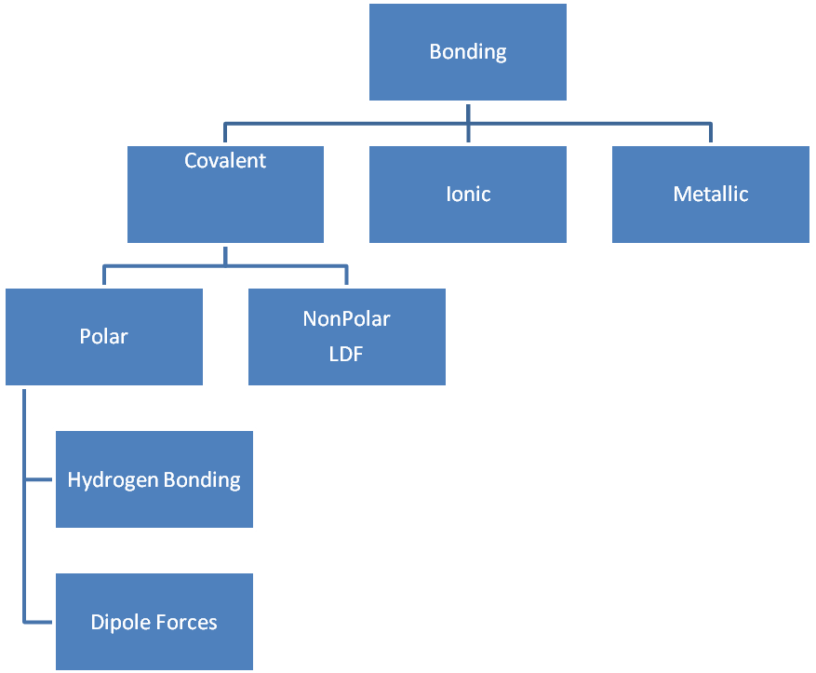
Polar Molecules:

Dipole-dipole: Sketch Here

Hydrogen Bonding: Sketch Here:
What does E.T. say: E.T. ____________ __________________

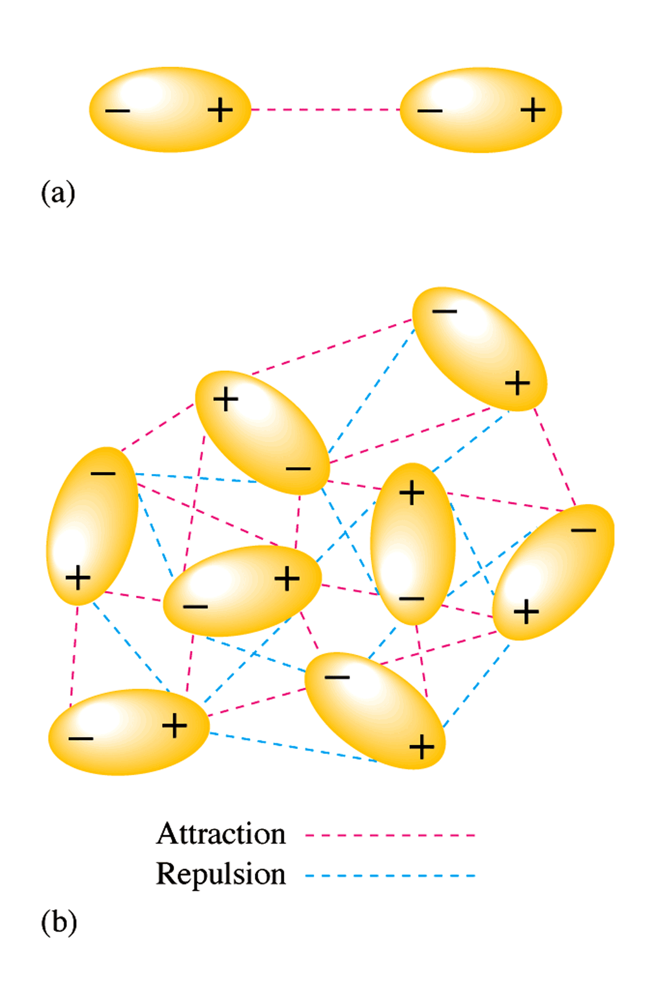
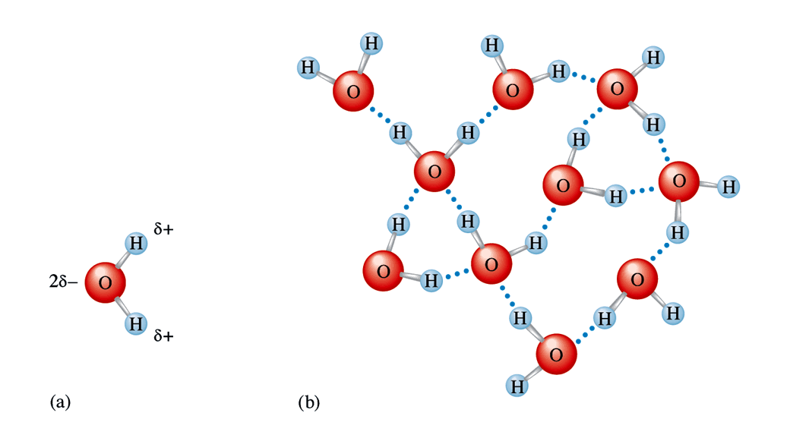
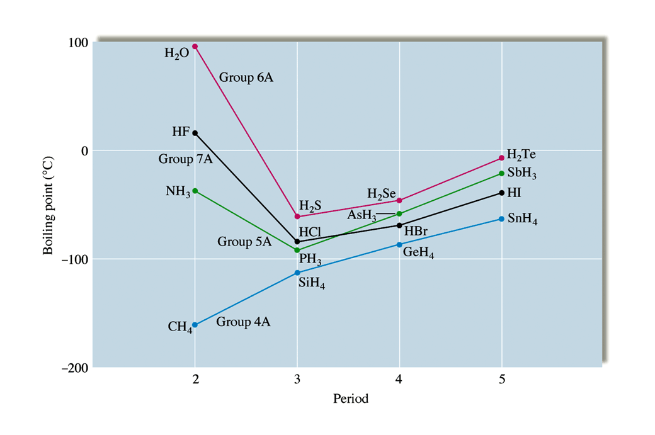
Nonpolar Substances: London Dispersion Forces

Sketch Here: O₂

Which molecules exhibit LDF forces?

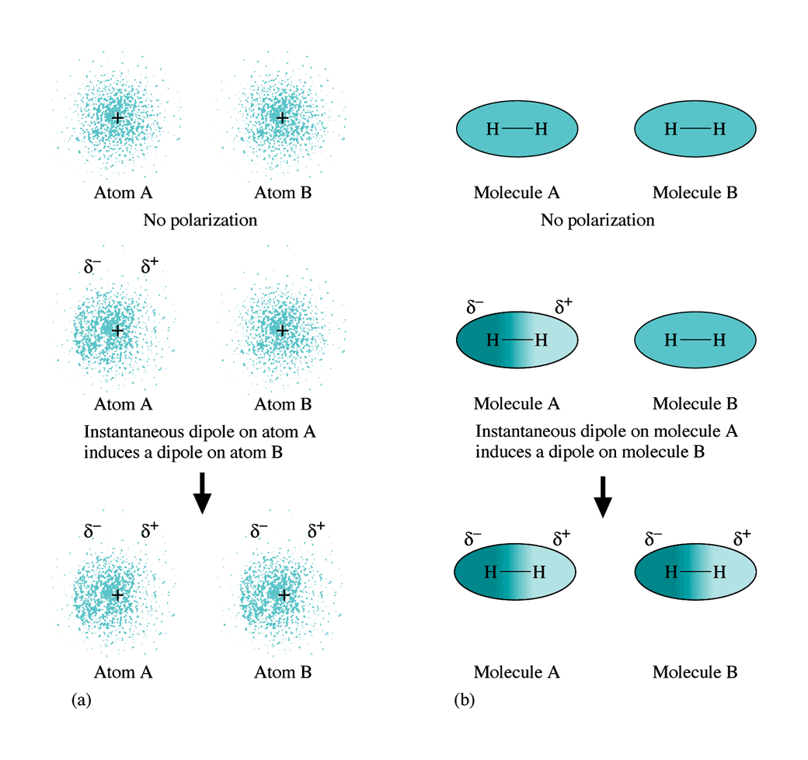
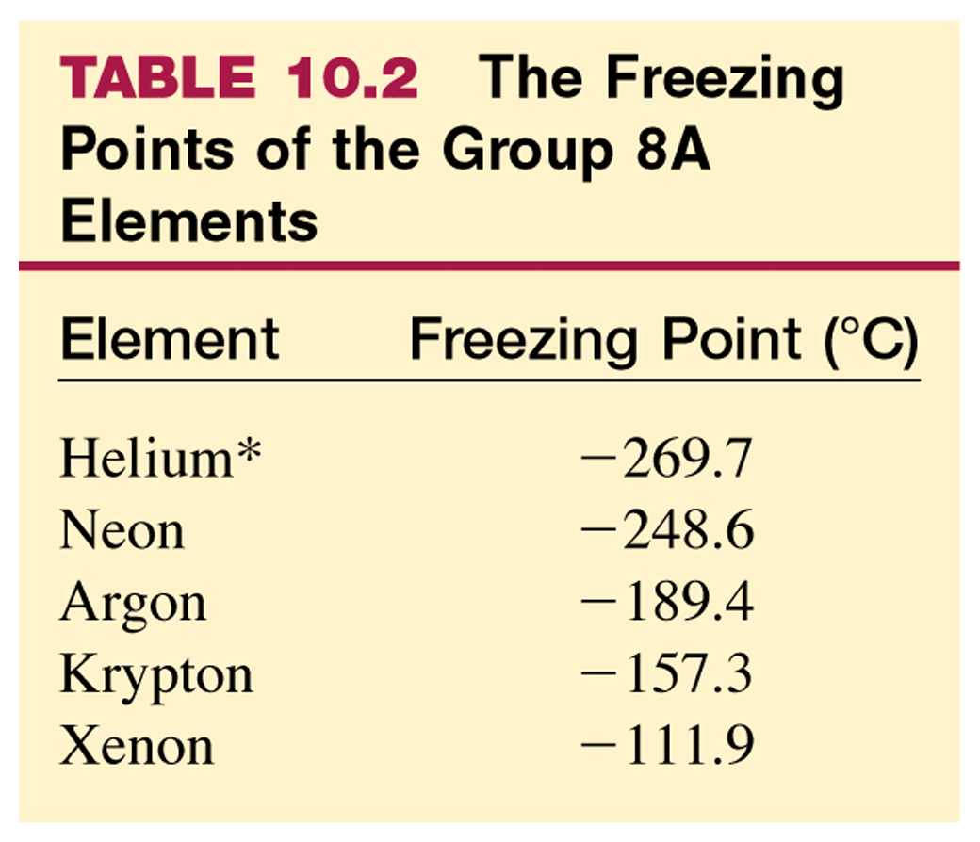
LDF and Size
The Bigger the molecule the ___________ the attractive forces and the ____________ the boiling point.
Large vs Small Molecules

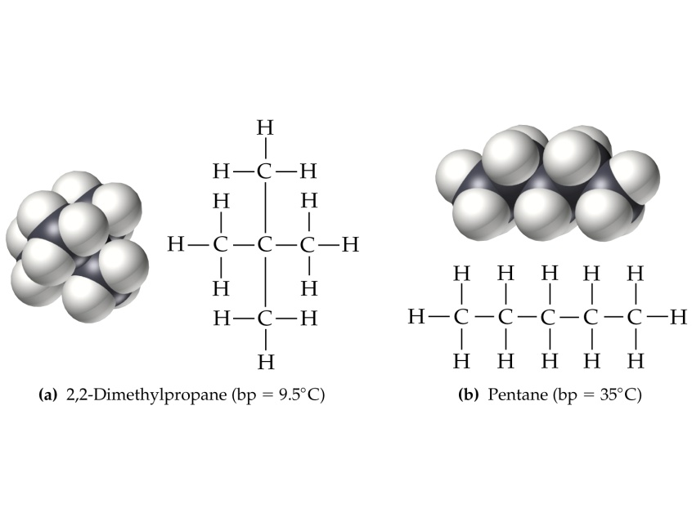
10.4: Metallic Bonding
The key player is the _____________ _____________________

Defining property of metals the _____________ electrons (and heat)

Sketch:

Explain:

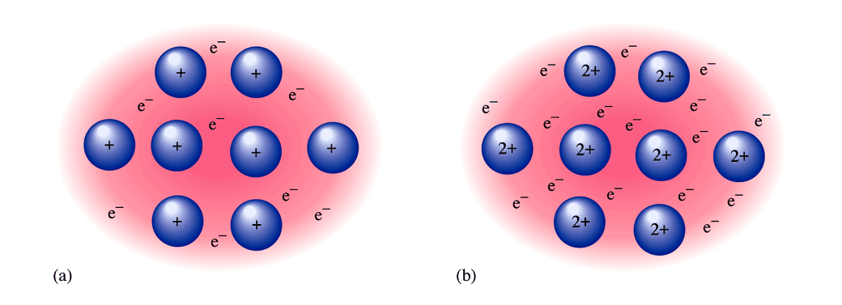
Sea of roving valence electrons holds metals together

Other interesting things about metals: Alloys
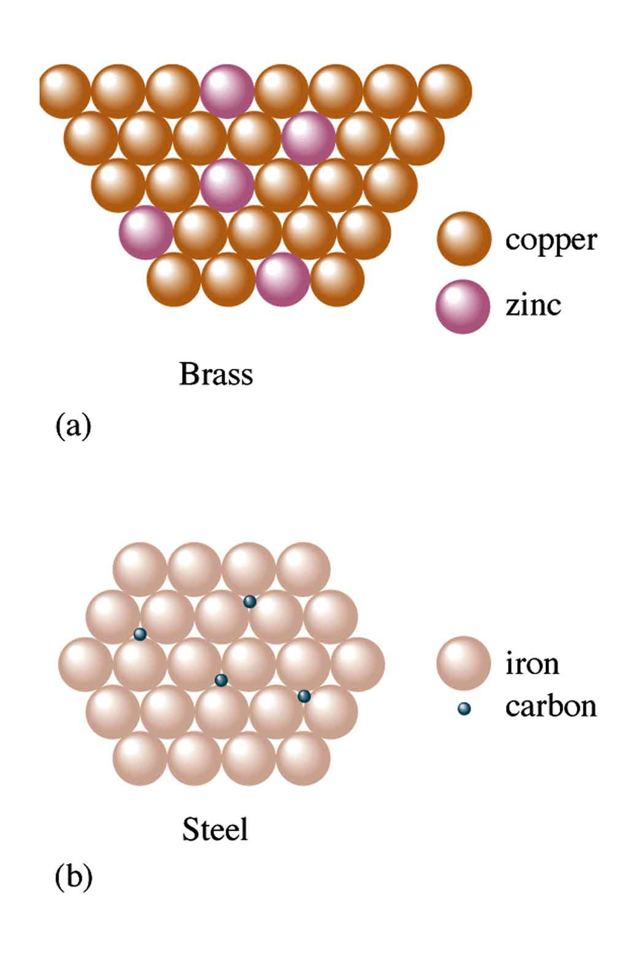

Substitutional Alloy

Interstitial Alloy

Why Malleable?

10.5: Network Solids
Molecules with all _______________ __________________

Only Compounds that contain _____________ & _________________

Examples

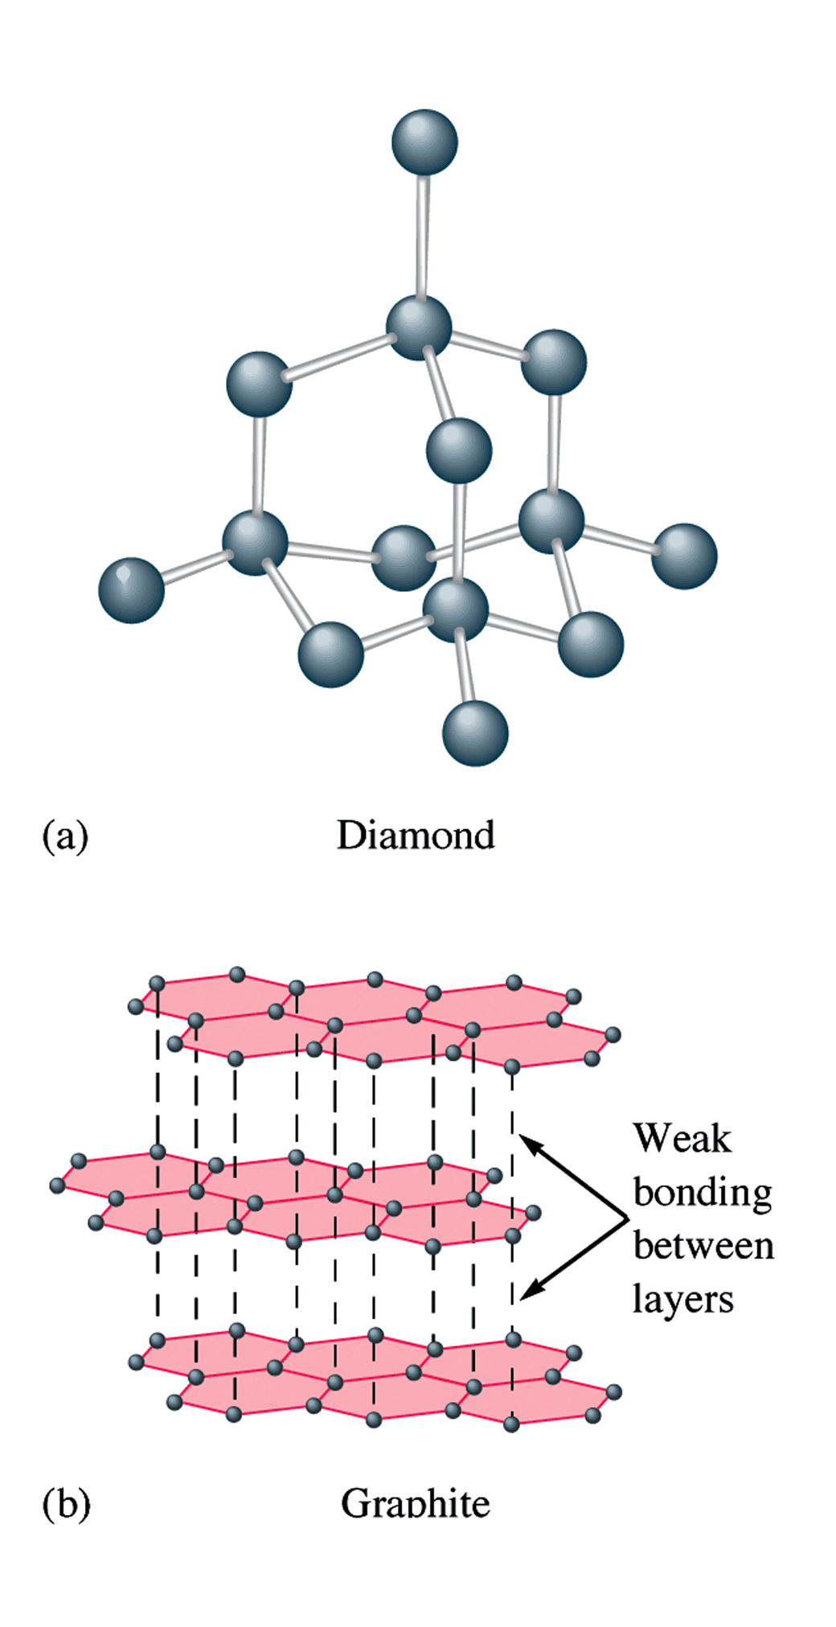
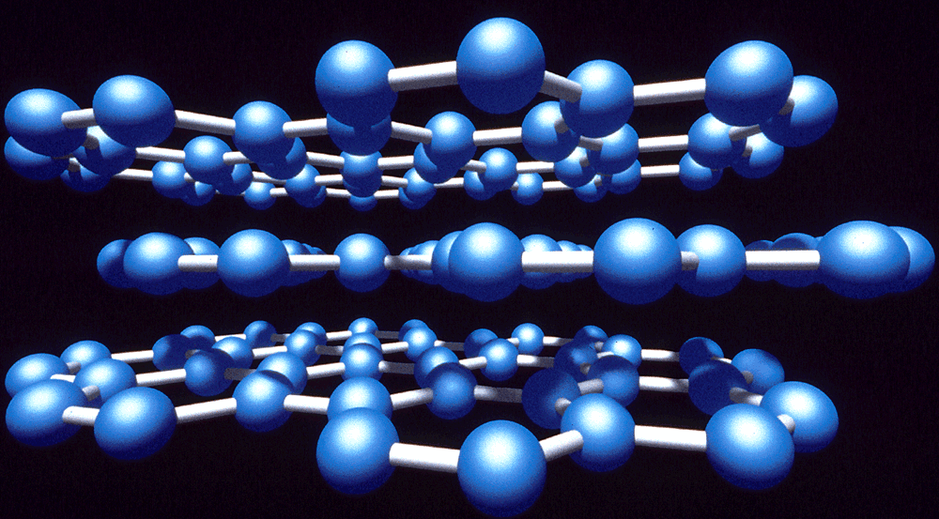
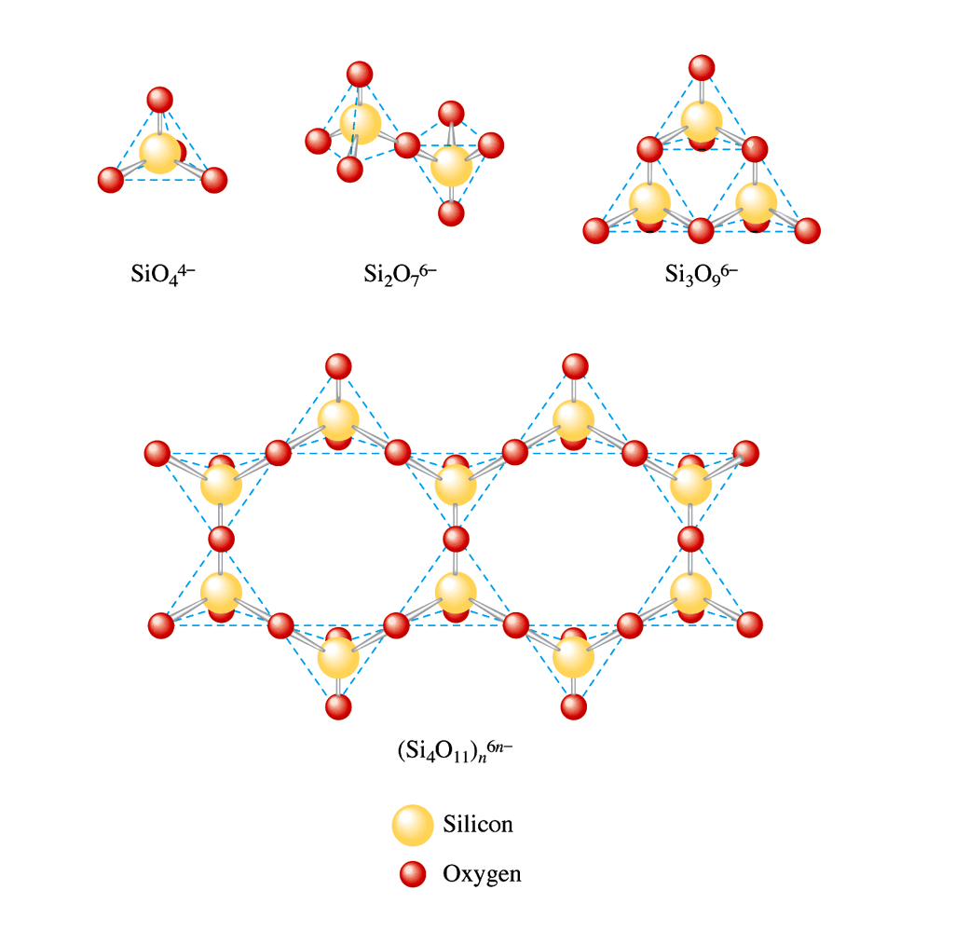

10.6: Molecular Solids (S₈, O₂, CO₂)

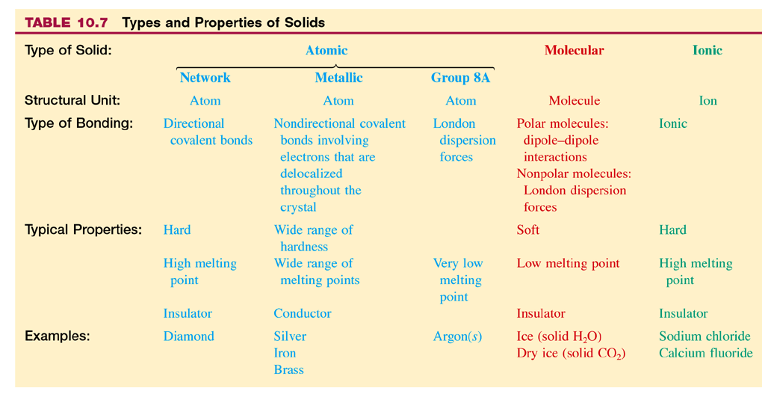
AP Style Questions
Explain each of the following in terms of atomic and molecular structures and/or intermolecular forces.
(a) Solid K conducts an electric current, whereas solid KNO3 does not.
(b) SbCl3 has measurable dipole moment, whereas SbCl5 does not.
(c) The normal boiling point of CCl4 is 77˚C, whereas that of CBr4 is 190˚C.
(d) NaI(s) is very soluble in water, whereas I2(s) has a solubility of only 0.03 gram per 100 grams of water.


